**Model Development Phase Template**

|  |  |
| --- | --- |
| Date | 20 June 2024 |
| Team ID | 740018 |
| Project Title | Determine : Loan from KIVA crowdfunding data |
| Maximum Marks | 4 Marks |

**Initial Model Training Code, Model Validation and Evaluation Report**

Initial model training code prepares and trains a predictive model. Model validation and evaluation report assesses performance metrics like accuracy and AUC, ensuring the model's reliability and effectiveness.

Top of Form

Bottom of Form

**Initial Model Training Code:**

Paste the screenshot of the model training code

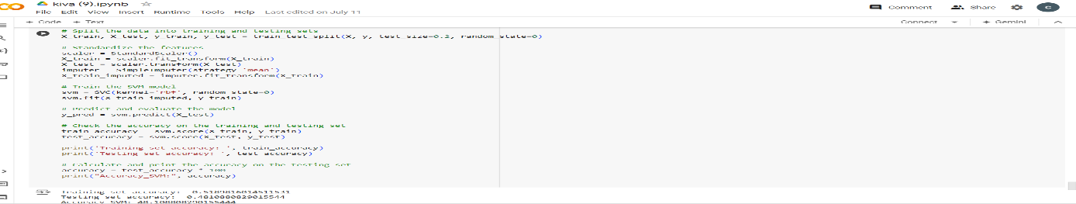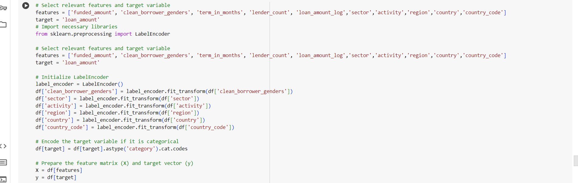

**Model Validation and Evaluation Report:**

|  |  |  |  |
| --- | --- | --- | --- |
| **Model** | **Classification Report** | **Accuracy** | **Confusion Matrix** |
| Randomforest  Classifier,  Decisiontree Classifier |  | 93% | --- |
| … | … | … | … |